Clerk Document of the nonprofit GCPTALKS
Oct/ 28/2021

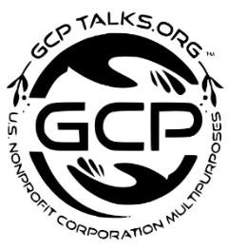

Dear nonprofit GCPTALKS Clerk (s) filing department, The General secretary acknowledges the document for staff and the public.

Due to our policies, it's the procedure of the nonprofit organization that the clerk register documents upon release.

The Communication Vice President dept must first have the approval from the Founder and President office before documents can be made public.

As for downloading, the founder and President's online office page will give access after the Special vice President office process the download access and seal.

The GCPTV media coverage shall review all contents and make info public through the supervision of authorities.

Document of GCPTALKS nonprofit and charitable organization

DOCUMENT ALL MADE FOR THE PUBLIC

AND DOCUMENT REGISTERED FOR THE PUBLIC AND NEWS.

Clerk signature
Secretary
Special Vice President
The Founder and President

Information verified

Learn More

Document at GCPTALKS
Email: gcp@gcptalks.org

